ArchestrA Keyword Extractor User Manual

October 2014

# Usage

The ArchestrA keyword exctractor is used to extract values from an object exported csv file based on a keyword. It is best explained by example:

Let’s say you have a composite object for an electrical motor and you want to export all the Tagname values, you will run the script by typing the script name followed by a space and the input csv file name (including path) followed by a space then the output file name (including the path) then a space and then the keyword Tagname. The same can be done for any keyword for example ShortDesc or PLCPath or Area or SecurityGroup etc. For examples see the “Example aaCSV Motor.csv” file (input file) and the “Example aaCSV Output.txt” file.

*Please note that the file format that is read have to be UTF-16-LE, this is the format that ArchestrA exports the csv files in.

# Prerequisites

The script is written in Python version 3.4. Python 3.4 is an easy to use programming language that is available free to download and easy to install and work with. You will need the following:

1. Python 3.4 installed on your PC
2. Python added to your path
3. The aaCSV.py script
4. The exported CSV file for your object

# Example

We want the Tagnames of a motor object in a list.

## The CSV File

First we export our Motor object CSV file. For easy use I exported it to the C:\ root directory.

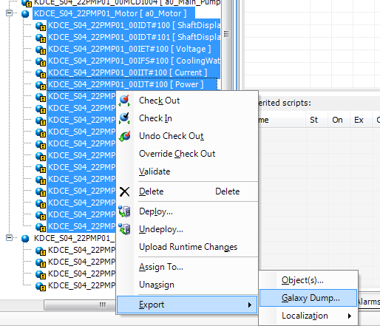

Figure 1.

It will look something like figure 2.

## 

Figure 2.

## Run the program

Open up the command prompt and change the directory to the path where your aaCSV.py file resides.

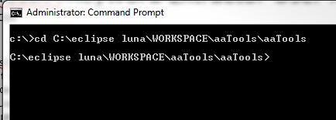

Figure 3.

Type in the program name followed by the CSV file followed by the new file name you want and followed by the keyword. See figure 4.

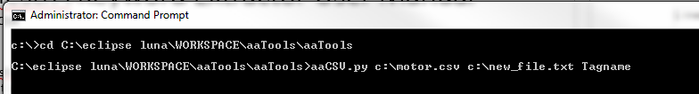

Figure 4.

Press enter and your file will be created.

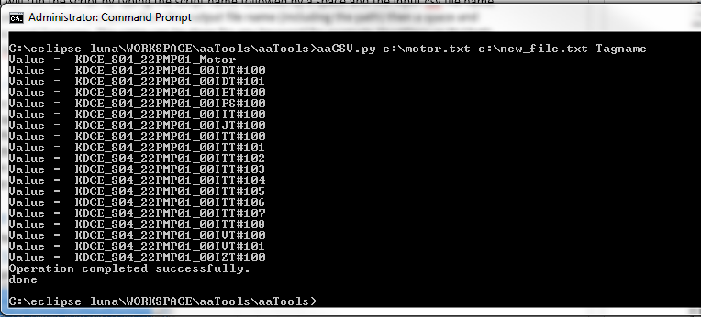

Figure 5.

The new_file.txt file contents will look like this:

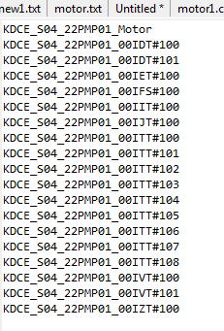

Figure 6.

That is it. All my tag names in a list one under the other, I can now use it in excel or for whatever I want to.

End.